In the name of beauty



The 8th problem set of Optical Networks course

* 1. What are the dedicated and shared path protection schemes and what are their differences?
  2. Categorize path protection and link protection as being either fault-dependent or fault-independent protection.

1. Consider the network topology in figure below. A lightpath is set up between nodes 1 and 8 along the link 1 -> 2 -> 5 -> 8. If link 2 -> 5 goes down, which of the following strategies will lead to a path with minimum number of hops? State the number of hopes in each case:

a) Path restoration b) Sub-path restoration c) Link restoration

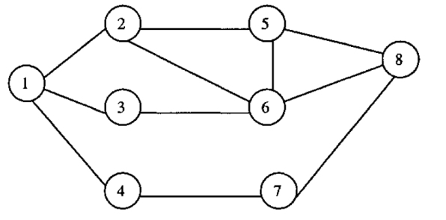

1. Suppose we have N : 1 protection (N primary paths protected by 1 shared backup) in the shown figure below. Each of the individual paths between S and D is available for data transmission with a probability of $p$ (the backup path b1 is shared for all the working paths p1 to pN). Calculate the probability that the single backup path b1 is not enough for transmission protection of all the paths p1 to pN**.**

**(Hint: i.e. the number of failure in working paths be 2 or more.)**

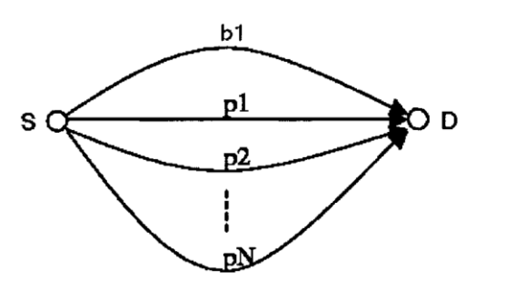

1. Consider the network shown below, and assume that a protected connection is desired between Nodes A and Z. If 1+1 protection is employed, how many different double-link failures can occur where the connection survives (i.e., either it recovers from the failures, or one, or both, of the failures does not affect it)?

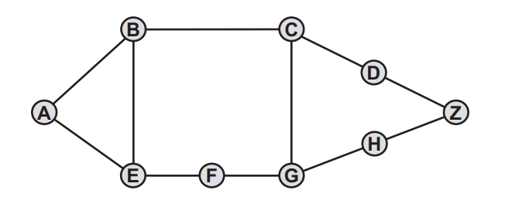

1. Consider the network topology and the traffic matrix shown below. Assume that adjacent nodes are connected by two fibers, one for the transmission in each direction.

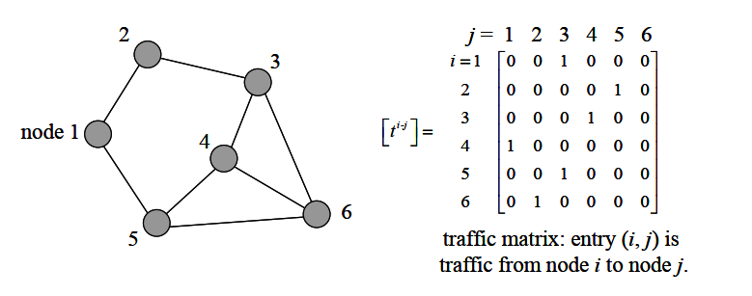

Assume that we want to provide 1+1 protection for failure recovery. In addition, assume that, after the routing problem, we find the following routes for all the lightpaths as shown below. Notice that there are two routes for each source-destination pair, one for the working path and the other for the protection path.

|  |  |
| --- | --- |
| s-d pair | Routes |
| 1-3 | 1→2→3, 1→5→4→3 |
| 2-5 | 2→1→5, 2→3→4→5 |
| 3-4 | 3→4, 3→6→4 |
| 4-1 | 4→5→1, 4→3→2→1 |
| 5-3 | 5→4→3, 5→6→3 |
| 6-2 | 6→3→2, 6→5→1→2 |

Keeping in mind that we wish to assign the same wavelength for both working and backup paths, construct a path graph so that node coloring of the path graph can give us the desired wavelength assignment for all the lightpaths.